EXECUTIVE SUMMARY

The Ozarks Chapter of the Institute of Transportation Engineers (OCITE) enjoyed an active year in 2016. In its thirteenth year as southwest Missouri's premier organization for transportation professionals, the Chapter grew its membership, increased attendance at its bi-monthly meetings, continued to offer many opportunities for professional development, networking, student engagement, and social activities. The OCITE service area includes twenty-four counties and includes the Springfield and Joplin metropolitan areas. Participants include professionals from state and local public agencies, consulting firms, vendors, and students, faculty and staff from engineering programs at Missouri State University in Springfield and Missouri University of Science & Technology in Rolla.

OCITE was pleased to grow the student scholarship fund with proceeds raised through the 2016 OCITE Technical Seminar and the inaugural OCITE Winter Classic Bowling Challenge and Social created to raise funds specifically for the scholarship fund. The event will hopefully continue on an annual basis. Through such efforts the Chapter can continue to award an annual scholarship to students with an interest in pursuing careers in Transportation. The 2016 Student Scholarship, in the amount of $400, was awarded to Kara Grunden from Missouri State University at the Annual OCITE Awards Banquet in December. In addition, the Chapter has taken an active role in getting more students involved in the organization. Chapter members participate in the annual Discover Engineering Day (hosted by Ozark Area Missouri Society of Professional Engineers) in February, the MSU Transportation Class Poster Competition (hosted by OCITE) in April, and the Chapter held its business meeting on the MSU campus in October. Students attend all OCITE business meetings free of charge.

The Chapter hosted its annual OCITE Technical Seminar on July 13 at the Lake Springfield Park Boathouse in Springfield, with 63 in attendance (including two students). The program for the day long seminar included 10 technical presentations from 13 speakers. OCITE is grateful to CJW, CMT, HDR, Olsson Associates, and Terracon for their sponsorship of the event. A Sponsor Reception was held at Big Whiskey's immediately following the seminar. The Chapter also conducted a food drive as part of the seminar and over 34 pounds of food was collected and donated to Ozarks Food Harvest.

The OCITE chapter meetings, held bi-monthly, were very well attended and offered a variety of presentation topics for the advancement of member awareness and professional development. The chapter hosted and/or promoted many other educational opportunities throughout the year.

In October, OCITE membership adopted an amendment to the Chapter Bylaws, and the Board approved revisions to the OCITE Policies. Significant effort was also put into updating and maintaining the OCITE website throughout the year with relevant up-to-date information.

A successful 2016 was celebrated at the annual OCITE Awards Banquet in December. In addition to the aforementioned 2016 student scholarship, presentations were made to receipts of the 2016 chapter awards. The Transportation Achievement Award was presented to City Utilities of Springfield for the newly completed Transit Center. The Transportation Professional of the Year Award went to Dane Seiler, President of CJW Transportation Consultants. The Distinguished Service Award was presented to Becky Baltz at the January 2017 business meeting. Becky, who recently retired as the MoDOT Southwest District Engineer, was unable to attend the Awards Banquet.

The Chapter remains financially healthy. Even with carryover expenses from the previous year and with a portion of revenue credited to the next year, OCITE increased assets by $305 for a total of $12,408.28 at year end.
2016 CHAPTER ADMINISTRATION

Board of Direction

The 2016 Board members were elected by OCITE membership, and the oath of office was administered at the December 2015 Awards Banquet by Jason Haynes, MOVITE Past President, the highest ranking ITE officer present. The OCITE Board members for 2016 are listed as follows:

2016 OCITE Board
President | Tom Dancey, P.E. | City of Springfield
Vice President | Paula Brookshire, P.E. | City of Springfield
Secretary | Steve Prange, P.E. | Crawford, Murphy, Tilley
Treasurer | Jonathan Staats, E.I. | CJW Transportation Consultants
Second Year Director | Sara Fields, AICP | Ozarks Transportation Organization
First Year Director | Andrew Flippin, P.E. | City of Springfield
Immediate Past President | Martin Gugel, P.E. | City of Springfield

The Board worked together throughout the year to discuss, plan, and carry out the administrative leadership of the Chapter. Specific board meetings occurred on the following dates: January 12, March 28, April 18, July 5, August 8, and November 28.

OCITE By-Law Amendment

The Board drafted a proposed amendment to the Chapter By-Laws and distributed to membership for consideration. The proposed changes included provisions for adoption of the annual budget at the first business meeting of the year (as opposed to Annual Meeting in December), clarification in filling a Board vacancy, update to list of meeting dates to avoid in scheduling business meetings, and other minor grammatical edits. Through a closed ballot vote at the October 26 business meeting, membership unanimously approved to adopted the proposed amendment.

OCITE Policy Revisions

The Board adopted Chapter Policy revisions on October 10, which included clarification on who prepares the Annual Report of Chapter Activities, updated references to student chapters, clarification on the annual December meeting, replacement of references to newsletter with chapter website, and other minor grammatical edits.

OCITE Chapter Website

Significant effort went in to updating and maintaining the chapter website, OCITE.org, throughout the year. Special thanks goes to Jason Saliba, Project Engineer with the City of Springfield, for his excellent work with the following improvements:

- Updated home page chapter information
- Updated Board of Direction contact information
- Added and maintained current OCITE scheduled events
- Added past year annual reports under Resources page
- Updated student scholarship information

2016 CHAPTER MEETINGS

The chapter meetings for 2016 provided for a diverse set of speakers, topics, and engagements. A description of each meeting is summarized below.

January
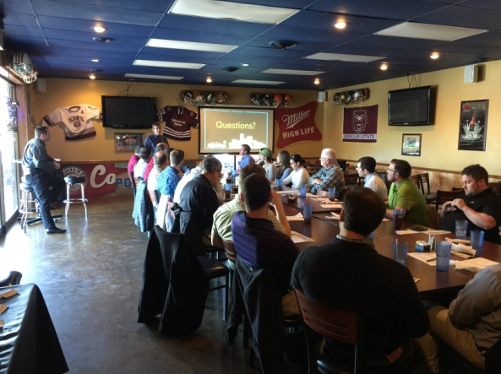
The first meeting of 2016 was held at Coyote's Adobe Cafe, and a presentation on the City of Springfield 1/4-Cent Capital Improvements and 1/8-Cent Transportation Sales Tax programs was given by City of Springfield Director of Public Works, Dan Smith. Other key items were discussed in the January meeting including 2015’s audit of finances, approval of the 2016 budget, and announcements of Discover Engineering Day volunteer opportunity, 2015 OCITE Scholarship recipient, Daniel Richards, and OCITE Winter Classic Bowling Challenge and Social benefiting the scholarship fund. A resolution of OCITE's support of both City of Springfield sales tax initiatives was presented to Mr. Smith by OCITE Secretary, Steve Prange. Below is an informational summary related to the January meeting:

Date | Location | Speaker | Topic | PDHs Awarded | Attendance
January 27 | Coyote's Adobe Cafe  Springfield, MO | Dan Smith | City of Springfield 1/4-Cent Capital Improvements and 1/8-Cent Transportation Sales Tax Programs | 0.5 | 27

March
The next chapter meeting was held on March 22 at Cantina Laredo in Springfield. Marc Thornsberry, Safety and Mobility Engineer with Federal Highway Administration, presented an update of the FHWA Missouri Division Program. Other keys items discussed include announcement of the Missouri State University Engineering Student Poster Competition, MOVITE Spring Meeting in Wichita, and 2016 OCITE Technical Seminar. Below is an informational summary related to the March meeting:

Date | Location | Speaker | Topic | PDHs Awarded | Attendance
March 22 | Cantina Laredo  Springfield, MO | Marc Thornsberry | FHWA Missouri Division Program Update | 0.5 | 32

May
The May chapter meeting was held at Avanzare Italian Dining in Springfield. Adam Humphrey, Assistant Administrator with the Greene County Highway Department, presented on the Kansas Expressway Extension project. Other items discussed include a recap of the MSU Engineering Student Poster Competition and MOVITE Spring Meeting, the call for abstracts for the MOVITE Fall Meeting, the OCITE Technical Seminar, and several professional development opportunities. Below is an informational summary related to the May meeting:

Date | Location | Speaker | Topic | PDHs Awarded | Attendance
May 24 | Avanzare Italian Dining,  Springfield | Adam Humphrey | Kansas Expressway Extension | 0.5 | 35

August
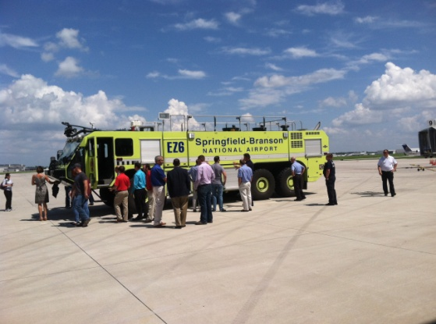
The August chapter meeting was held at Springfield-Branson National Airport and had many items on the agenda. Old business included a recap of the 2016 OCITE Technical Conference, Midwestern District Meeting in Chicago and the ITE Annual Meeting in Anaheim. OCITE is honored to have had one of its members elected to the MWITE Board--congratulations to Martin Gugel, 2017 MWITE Secretary-Treasurer. New business included announcements of the MOVITE Fall Meeting in Oklahoma City and the Annual OCITE Golf Tournament. In addition, the aforementioned OCITE By-Law Amendment was presented to membership and revisions to OCITE Policies under consideration by the Board were outlined. The 2016 OCITE Scholarship Application was announced, and the formal call went out for nominations for the 2017 OCITE Board. Following the chapter business portion of the agenda, Brian Weiler, Director of Aviation, provided a presentation of existing and planned operations for the airport followed by a "behind the scenes" tour of the airport terminal and facilities. Below is an informational summary related to the August meeting:

Date | Location | Speaker | Topic | PDHs Awarded | Attendance
August 25 | Springfield-Branson National Airport | Brian Weiler | SGF Airport  Presentation and Tour | 0.5 | 34

October
In keeping with OCITE tradition, the October chapter meeting was located on the Missouri State University campus to encourage increased student attendance. As with all OCITE chapter meetings, students attended free of charge. Old business included a recap by Jason Haynes of the MOVITE Fall Meeting, section awards, and board election results. OCITE is honored to have received the 2015 Chapter Award and to have two members elected to the MOVITE Board--congratulations to Eric Claussen (Board Director) and Dane Seiler (Missouri Director). Other old business included a recap of the 2016 OCITE Golf Tournament, announcement of call for 2017 Board nominations, 2016 OCITE Scholarship, and membership vote of proposed OCITE By-Law Amendment. The amendment was approved unanimously. New business included the call for 2016 OCITE Award nominations and announcement of a volunteer opportunity at the Nixa Junior High Annual Awareness Day. Dr. Doug Carroll, Director of the Missouri S&T/Missouri State University Cooperative Engineering Program, provided an overview/update of the program. The meeting concluded with a presentation on the Missouri State University Visioning Guide Update provided by Doug Sampson, University Architect/Director of Planning, Design & Construction. Below is an informational summary related to the October meeting:

Date | Location | Speaker | Topic | PDHs Awarded | Attendance
October 26 | Plaster Center for Free Enterprise Springfield, MO | Doug Sampson | Missouri State University Visioning Guide Update | 0.5 | 35

2016 OCITE TECHNICAL SEMINAR

The Chapter hosted its annual OCITE Technical Seminar on July 13 at the Lake Springfield Park Boathouse in Springfield, with 63 in attendance. The program included a wide variety of technical presentations from 13 speakers:

- Project Freeway: U.S. 60 Rogersville MoDOT Design-Build, Sean Matlock & Greg Chapman, MoDOT Southwest District
- Real-Time Travel Time Data Collection, Brian Doubrava, City of Springfield, MO
- Statewide Transportation Improvement Plan Update, Frank Miller, MoDOT Southwest District
- Traffic Management Considerations for Implementation of a Temporary Diverging Diamond Interchange; A Case Study of 2015 Improvements at U.S. 65 & Battlefield Road, Reid Catt, Olsson Associates and Jim Fisher, Hartman & Co.
- Overview of Multimodal-Rail Division, Troy Hughes, MoDOT Central Office
- MoDOT's LPA Program, Liz Prestwood, MoDOT Central Office
- I-70 Rural Queue and Delay Warning System, Mark Sommerhauser, Kansas City Scout
- What are Complete Streets and Why Should I Care?, David Hutchison, City of Springfield, MO
- Bicycling in Denmark, Nathan Becknell, City of Rogers, AR
- Rebuilding After the Storm, Nick Heatherly & Dan Johnson, City of Joplin, MO

A Sponsor Reception was held at Big Whiskey's immediately following the seminar. Special thanks to CJW Transportation Consultants, CMT, HDR, Olsson Associates, and Terracon for their sponsorship and continued chapter support. A food drive was also conducted as part of the seminar, and over 34 pounds of food was collected and donated to Ozarks Food Harvest.

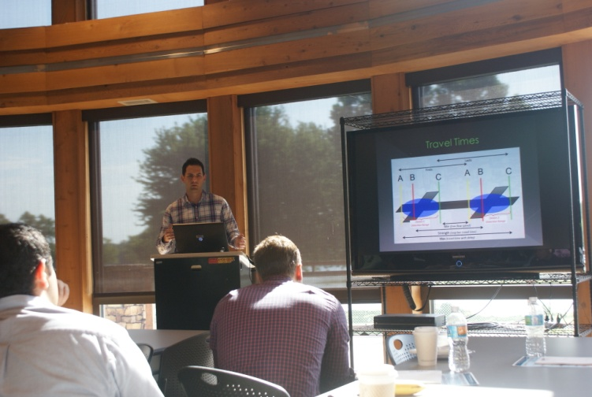
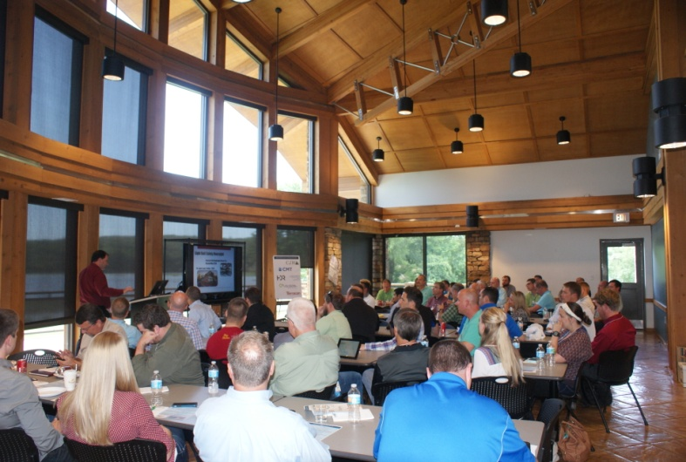

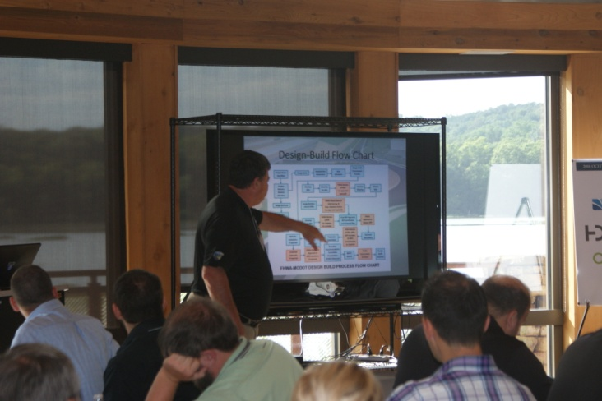

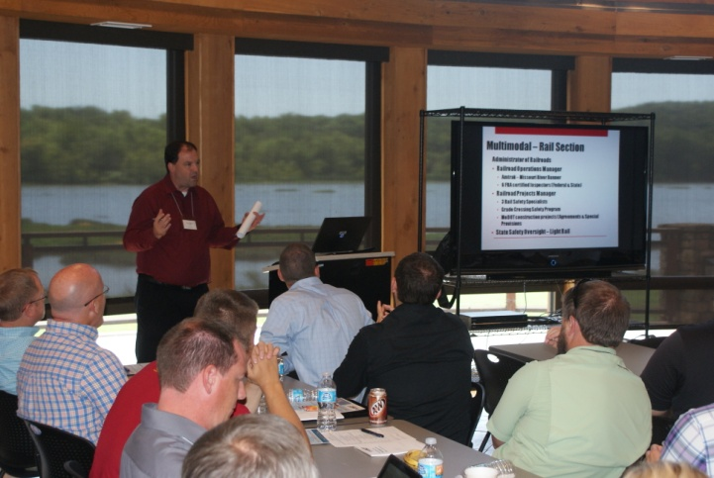
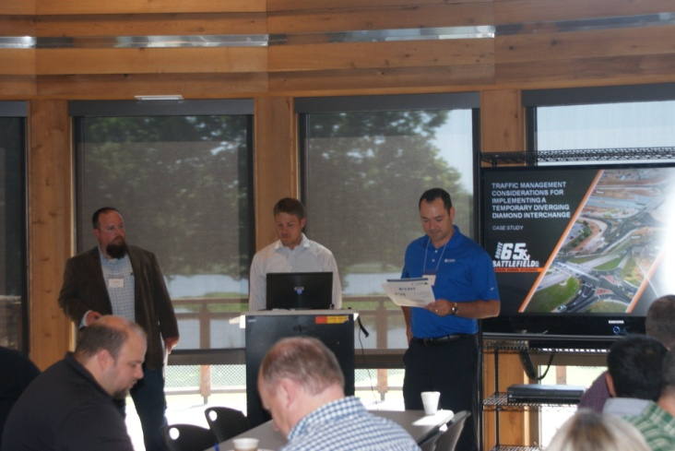

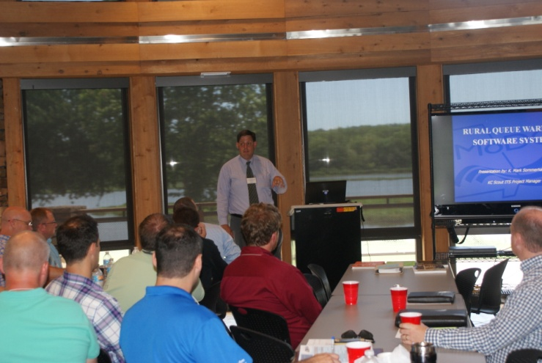
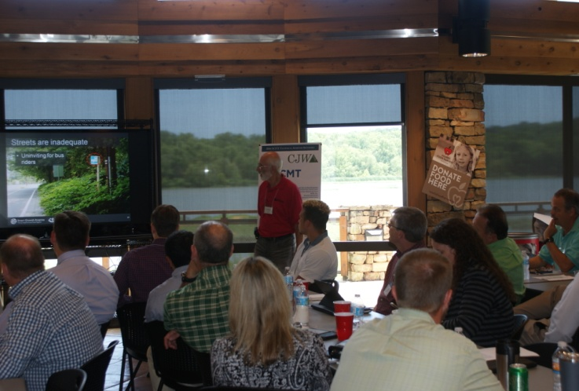

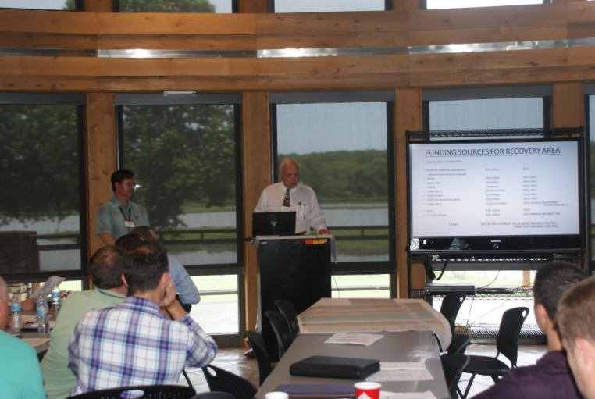
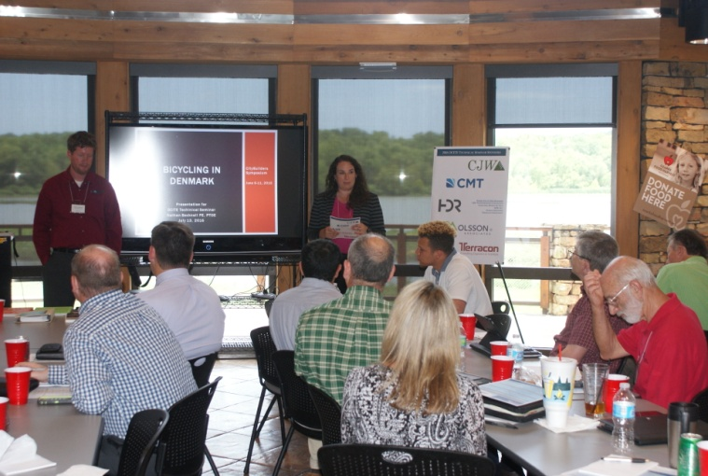

OTHER PROFESSIONAL DEVELOPMENT ACTIVITIES

OCITE hosted and/or helped to promote numerous other technical activities to provide professional development opportunities to the Ozarks region. The Chapter helped to promote Work Zone Temporary Traffic Control Technician, Traffic Signal Technician Level 1, and Traffic Signal Field Technician Level II IMSA certification classes held March 14-18 at the Transportation Management Center in Springfield. OCITE hosted the FHWA Older Driver and Pedestrian Design Workshop on May 18 and the FHWA Introduction to Performance-Based Practical Design Webinar on September 15. Both were held at the TMC in Springfield.

The Chapter helped to promote the U.S. Access Board Accessible Pedestrian Signals webinar held May 5 at the City of Springfield Busch Municipal Building; Doing Business with MoDOT seminar held June 6 at the Library Center; FHWA "TSMO - What Does it Mean for Planners" webinar held June 16 at the TMC; EDC Exchange for Local and Tribal Agencies "Smarter Work Zones" webinar held June 23 at the TMC; APBP "Performance Measures to Evaluate Street Design" webinar held July 28 at the TMC; Building Public and Political Support for Transit workshop on August 17; and APBP "Advancing Vision Zero" webinar held August 23 at the Busch Municipal Building.

2016 OCITE AWARDS BANQUET

The Chapter has a long tradition of recognizing our peers’ accomplishments through the Annual OCITE Awards Banquet held in December. Held at Vito's Kitchen in downtown Springfield with 34 in attendance, OCITE recognized three very deserving individuals and projects and presented the 2016 OCITE Student Scholarship.

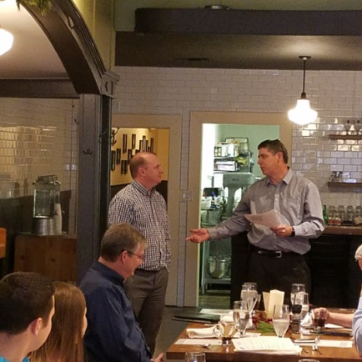
Transportation Professional of the Year: Dane Seiler

Dane Seiler, 2013 OCITE President, was the recipient of the 2016 Transportation Professional of the Year award for his many contributions to the transportation profession. He was recently named President of CJW Transportation Consultants, has been an adjunct instructor at Missouri State University since 2011, and has been actively involved at many levels within ITE. Dane is a graduate of the 2016 class of LeadershipITE and was just elected as Missouri Director on the MOVITE Board.
Jay Wynn (r) presents Dane Seiler (l) with the Transportation Professional of the Year Award

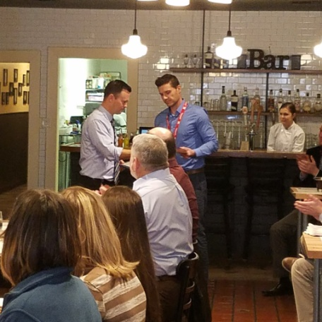
Transportation Achievement Award:
City Utilities of Springfield, Transit Center

The 2016 Transportation Achievement Award went to City Utilities of Springfield for the design and construction of the Springfield Transit Center. The new transit center, which opened in May 2016, provides better space to accommodate larger buses and expanded fleet and a safer facility with modern amenities. CU Transit also redesigned transit routes to provide more efficient service and better access to employment and essential services.
Kelly Turner (l) accepts the Transportation Achievement Award on behalf of City Utilities of Springfield from Eric Claussen (r)

Distinguished Service Award: Becky Baltz

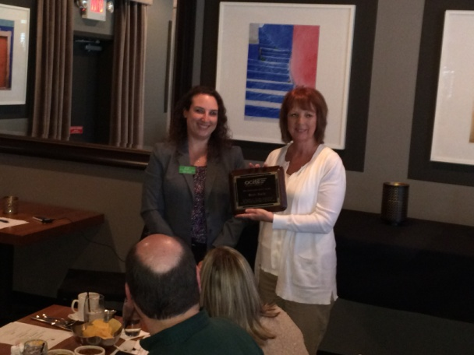
Becky Baltz was recognized for over 32 years of service and significant contribution to the Transportation Engineering profession with 2016 OCITE Distinguished Service Award. Becky began her career with the Missouri Department of Transportation in 1984 where she went on to hold many positions with MoDOT. When she was named District Engineer in 2006 for District 7 in Joplin, Becky became at that time only the second female ever to hold the title at MoDOT, and throughout her career she continued to search for ways to attract young women into the engineering profession. Becky led the restructuring of Districts 7 and 8 into what is now the Southwest District, where she continued as District Engineer from 2011 until her retirement in November 2016. Becky was unable to attend the Awards Banquet, but she was presented her distinguished award at the January 2017 meeting.
Sara Fields (l) presents Becky Baltz (r) with the 2016 Distinguished Service Award

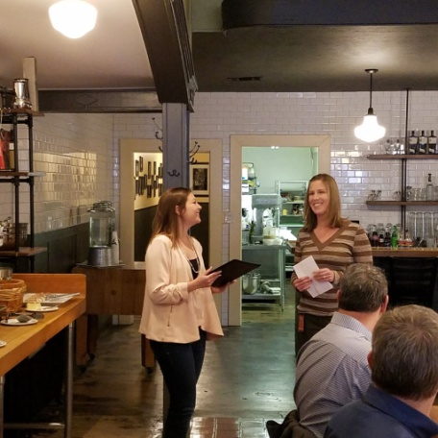
2016 OCITE Student Scholarship:
Kara Grunden, Missouri State University

The 2016 OCITE Student Scholarship was awarded to Kara Grunden, senior at Missouri State University. Kara anticipates graduating in December 2017 with a degree in Civil Engineering. In addition to her academic training, Kara has been gaining valuable engineering experience through her Design internship with MoDOT in since October 2015.

Kara Grunden (l) is presented by Paula Brookshire (r) with the 2016 OCITE Student Scholarship

Election and Installation of 2017 Board

The only official business conducted at the Awards Banquet was the closing of nominations and election of the 2017 Board of Directors. With candidates running unopposed for each position, the new board was elected by acclamation, and the oath of office was administered by Jason Haynes, 2015 MOVITE President, the highest ranking ITE member in attendance. The OCITE Board for 2017 is listed as follows:

2017 OCITE Board
President | Paula Brookshire, P.E. | City of Springfield
Vice President | Steve Prange, P.E. | Crawford, Murphy, Tilley
Secretary | Jonathan Staats, E.I. | CJW Transportation Consultants
Treasurer | Andrew Flippin, P.E. | City of Springfield
Second Year Director | Sara Fields, AICP | Ozarks Transportation Organization
First Year Director | Frank Miller, AICP | Missouri Department of Transportation
Immediate Past President | Tom Dancey, P.E. | City of Springfield

SPECIAL EVENTS

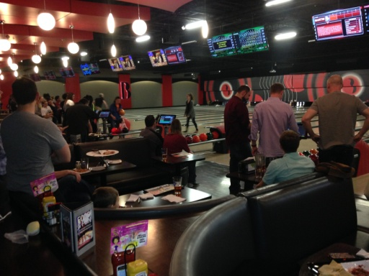
OCITE Winter Classic Bowling Challenge & Social
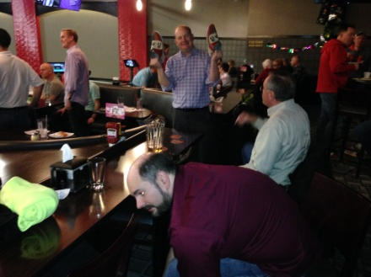
The inaugural OCITE Winter Classic Bowling & Social was held on February 25 at Andy B's Family Event Center in Springfield. A total of 27 participants made up five teams for some friendly bowling competition. Lee Engineering prevailed in the team competition, and Jason Haynes took home the individual competition title. Not only did the event make for a very fun evening, but it brought some new faces to OCITE and it raised $242.63 for the Student Scholarship Fund. The successful event will hopefully become an annual OCITE tradition.

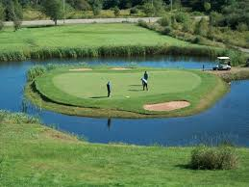
OCITE Annual Golf Tournament
The 11th Annual OCITE Golf Tournament was held on October 14 at Island Green Golf Club in Republic, MO. 36 golfers enjoyed a cool, overcast, but mostly dry (a few errant shots not withstanding) outing. Congratulations to the team made up of Chris Dunnaway, Brett Foster, Eric Shelton, and Jared Rasmussen for topping the field. Jared Davis, Aaron Hargrave, Brad Chadwick, and Bobby Laird took second place honors. Other prizes where given for longest drive (Brett Foster) and closest to the pin (Adam Humphrey). The event provided great fellowship among OCITE members and non-members alike. A big thank you to our sponsors, Anderson Engineering, CJW, CMT, HDR, and Terracon, who helped make it possible.

STUDENT ACTIVITIES

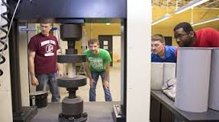
OCITE continues to take an active role in getting students involved in the organization, particularly those from the Missouri State University Cooperative Engineering Program with the Missouri University of Science & Technology. Students were present at every Chapter meeting, with two also attending the Technical Seminar. In addition, the Chapter once again hosted the Missouri State University’s Transportation Class student poster session. At the session, students had the opportunity to present their class project, work on their public speaking skills in a “public meeting” type setting, and talk with other local transportation professionals.

More importantly, our membership and their companies are realizing the fresh talent from the new civil engineering graduates from this program as well as the Missouri University of Science & Technology. They are hiring these students as interns and full-time employees, and they are adding to the number of transportation professionals in the Southwest Missouri area.

This year OCITE continued the tradition of hosting its October business meeting at the Missouri State Engineering Department’s building. At this meeting we direct the subject matter towards students, inviting the faculty, and students. This resulted in an increase in attendance from the students.

2016 CHAPTER OVERVIEW

Membership

At the end of 2016, there were 98 individuals on the active roster with 77 members in good standing with the Chapter. Members include local transportation professionals from state, county, and city government, public organizations such as the metropolitan planning organization, consulting professionals, and transportation equipment vendors. 2016 also saw continued participation by both faculty and students from Missouri State University’s cooperative engineering program with the Missouri University of Science & Technology.

Chapter Dues

Chapter Members pay annual dues of $10. As an incentive, agencies and businesses that pay for their employees’ membership dues on one invoice pay $10 for the first employee to be a member, and then $9 for each other member thereafter. OCITE uses these annual dues to help offset costs for chapter meetings, printing, and postage.

The 2016 Budget was unanimously approved by the membership at the January 27 Chapter Meeting. A copy of the approved yearly budget can be found the Appendix.

Financial Statement

The Chapter remains financially healthy. Even with carryover expenses from the previous year (MWITE District Meeting and 2015 Scholarship) and with a portion of revenue credited to the next year (Awards Banquet revenue), OCITE increased assets by $305 for a total of $12,408.28 at year end. The Board restructured the bank accounts at the beginning of the year, adding a savings account specifically designated for the Scholarship Fund and leaving the other savings designated as chapter reserves. Below is a summary for each Chapter account. A copy of the 2016 Annual Financial Statement can be found in the Appendix.

Checking Account (Operating Funds)
Beginning Balance | $2,569.57
Income | 9,595.65
Expenses | (11,063.63)
Net Over Period | (1,467.98)
End of Year Balance | $1,101.59

Savings (Chapter Reserves)
Beginning Balance | $8,814.93
Income | 4.59
Expenses (Transfer to Scholarship Fund) | (4,373.63)
Net Over Period | (4,369.04)
End of Year Balance | $4,445.89

Savings (Student Scholarship Fund)
Beginning Balance | $0.00
Income (includes transfer of $4,373.63 from Chapter Reserves) | 6,813.17
Expenses | (52.37)
Net Over Period | 6760.80
End of Year Balance | $6,760.80
Federal Employer Identification Number: 74-3080630

